Guilin Bravo Hotel (桂林宾馆)

Address: Address: No.14 South Ronghu Road, Guilin, 541002, Guangxi, China

Front Desk Telephone: (+86) 773-2898888

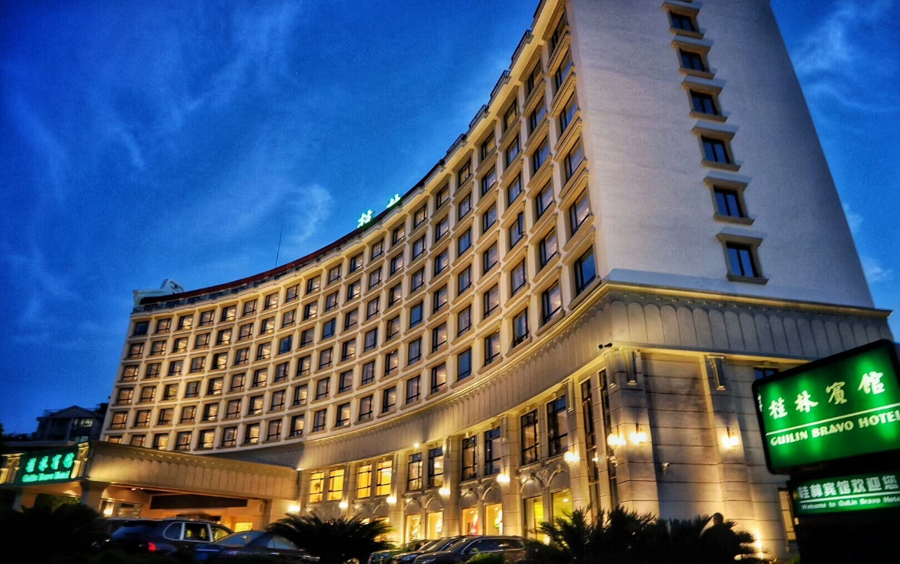

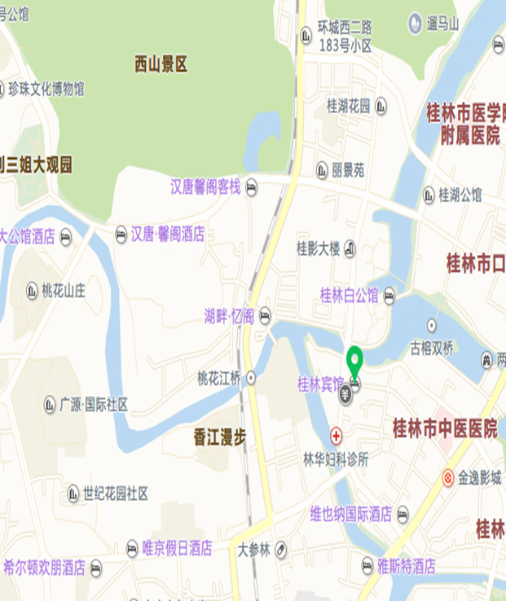

Traffic：

1. Conveniently located in the Dream of water center on the Banyan Lake Park

2. Guilin Liang Jiang International Airport: 28km

3. Guilin Railway Station: 3km

4. Elephant Tunk Hill Park: 1km